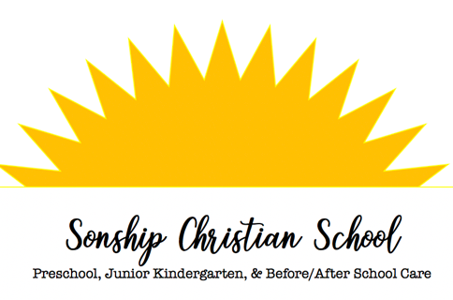

24905 Witte Rd. SE/ PO Box 466 Maple Valley, WA 98038-1980
425-432-1980

Preschool:
Classes are phonics based, hands on, with a mixture of social and academic times. Children are taught letter recognition and letter sounds through the “letter of the week” in which all object lessons are structured around that letter’s sound (e.g. “P-p-p-p painting with p-p-p pudding”). The students will learn to identify colors, shapes, and numbers.
Classes are divided into morning and afternoon sessions.
Morning: 8:30-11:30
Afternoon: 12:30-3:30.
Classes-Max 10 children per class.
Ages 2 ½ - 3 ½ are on Tuesdays and Thursdays
Ages 4 & 5 on Mondays, Wednesday, and Fridays
Junior Kindergarten:
Excellent transition class between Preschool and Kindergarten, for students who are not old enough for Kindergarten (turn 5 before September 1st). This program features a very structed academic program. The children will learn to write, recognize and know the sounds of the letters, count to 100, and begin to read short-vowel words.
Five day a week program – Max 11 children per class
Ages 4 ½ - Kindergarten
Morning: 8:30-11:30
Afternoon: 12:30-3:30
Daycare:
We offer daycare for children ages 3-10 years of age from September through June, and provide transportation to and from Tahoma District Elementary Schools (Glacier Park, Lake Wilderness, Rock Creek). Our daycare program is set up on a flexible schedule, so you only pay for the hours you actually use. We appreciate the opportunity to serve your family and support your desire to provide a strong foundation for your child’s success.

